1. A report that contains all answers to the relational algebra queries. If you think that it helps your case you should add a brief explanation of why you wrote the query the way you did. If you add such a short explanation you will be able to get part marks in case of a mistake

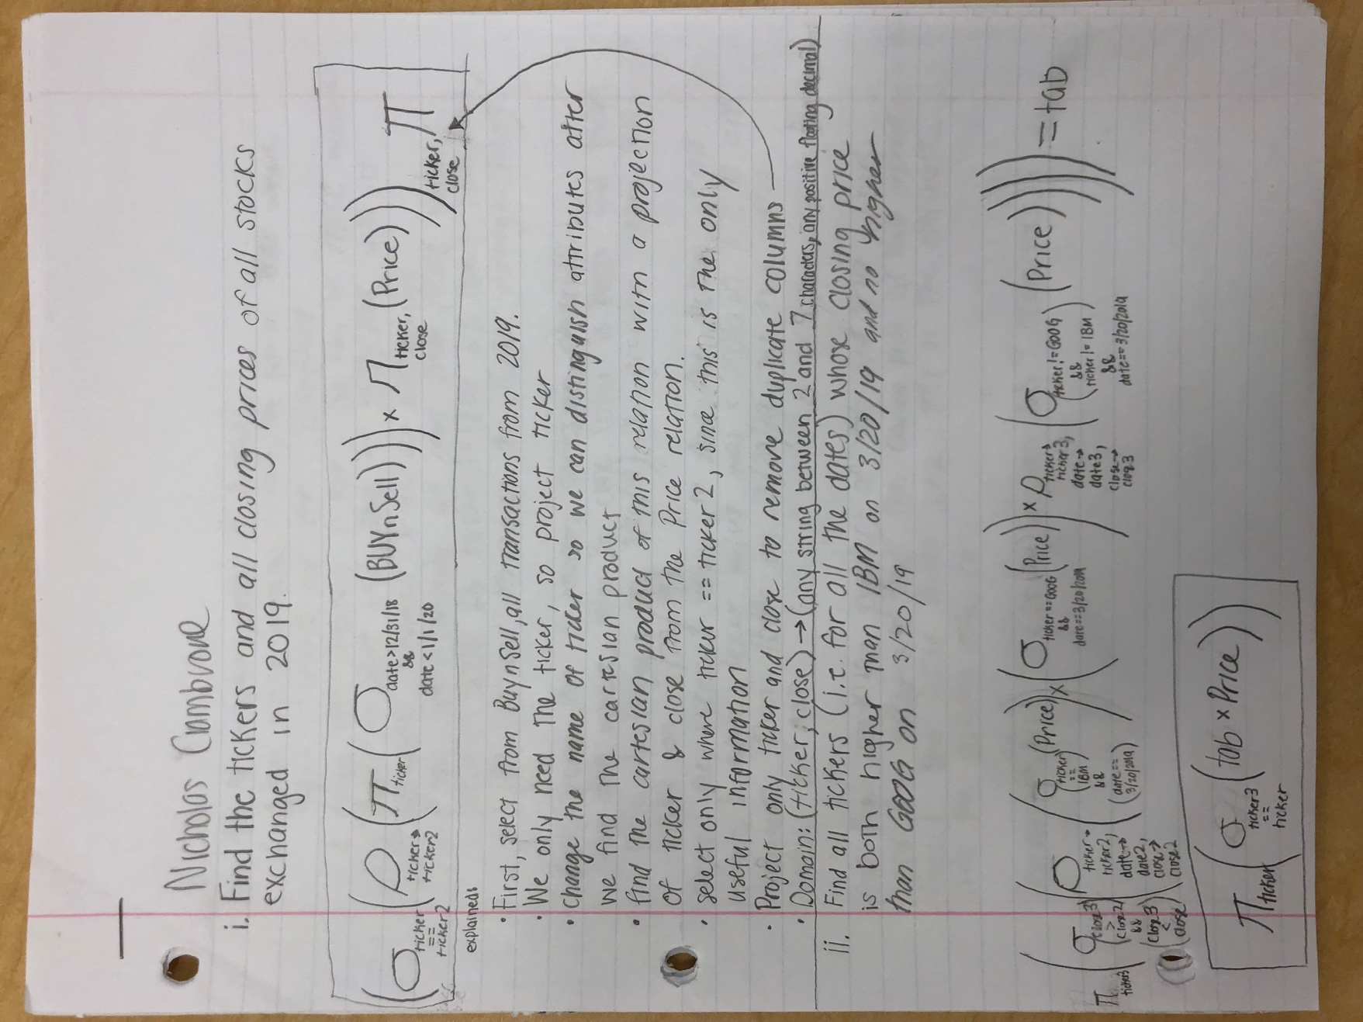

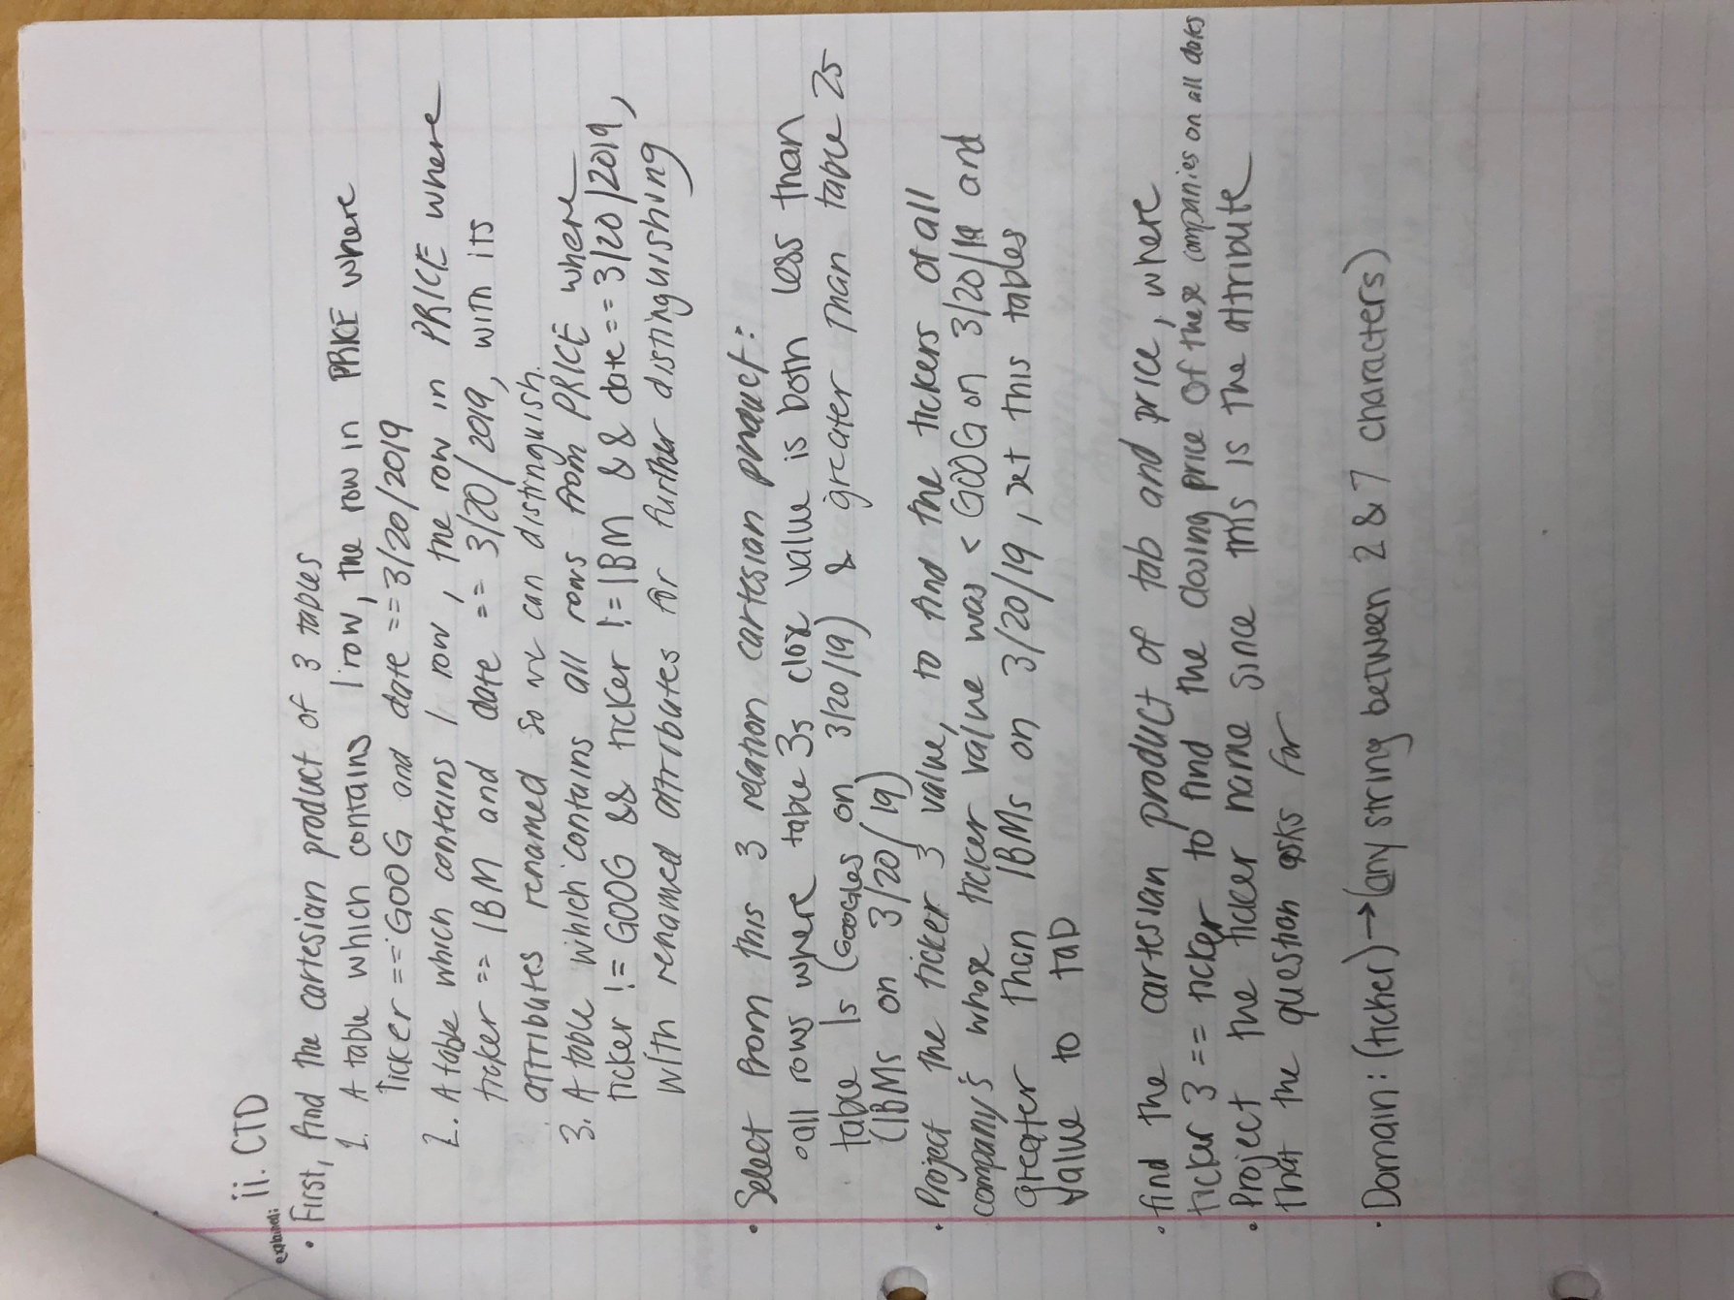

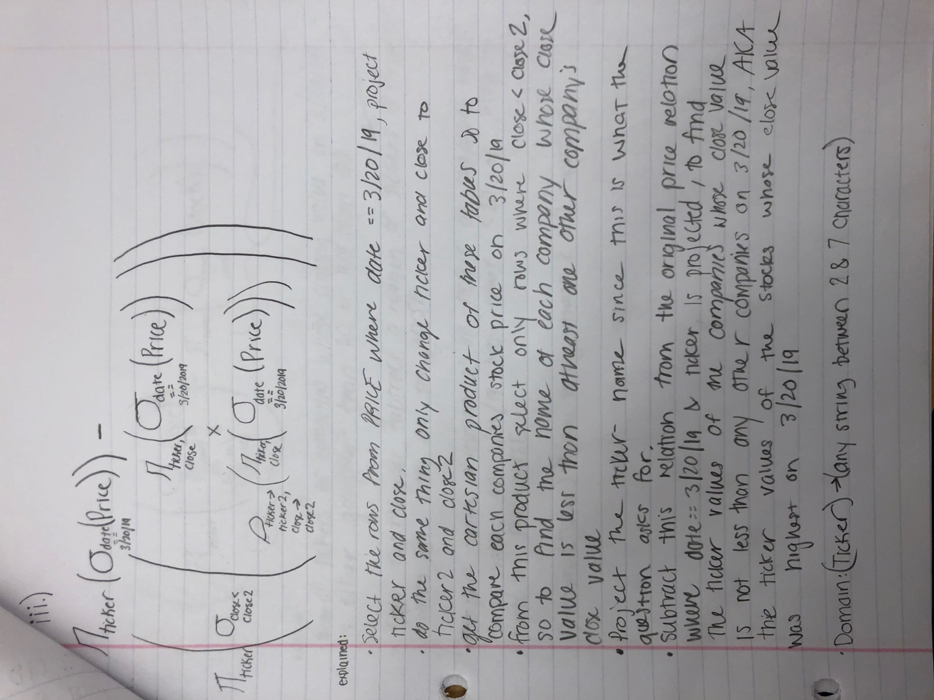

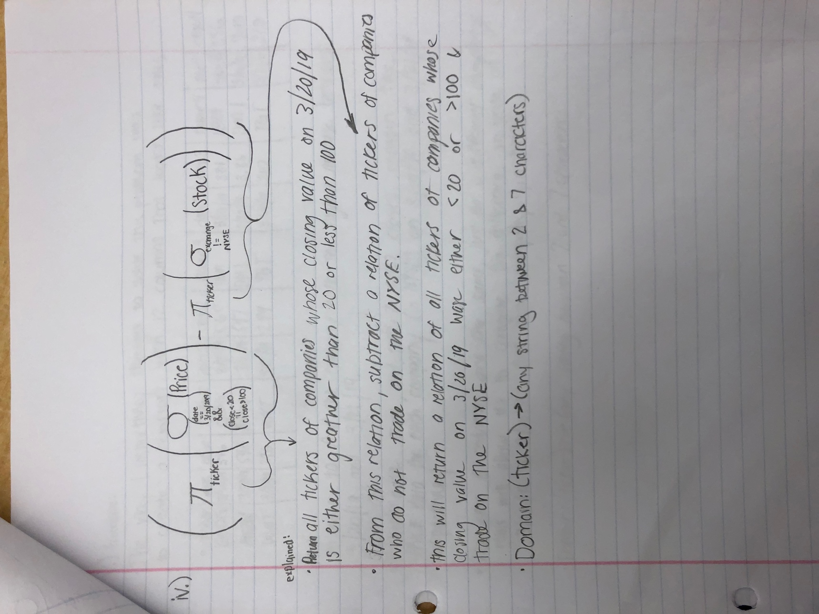

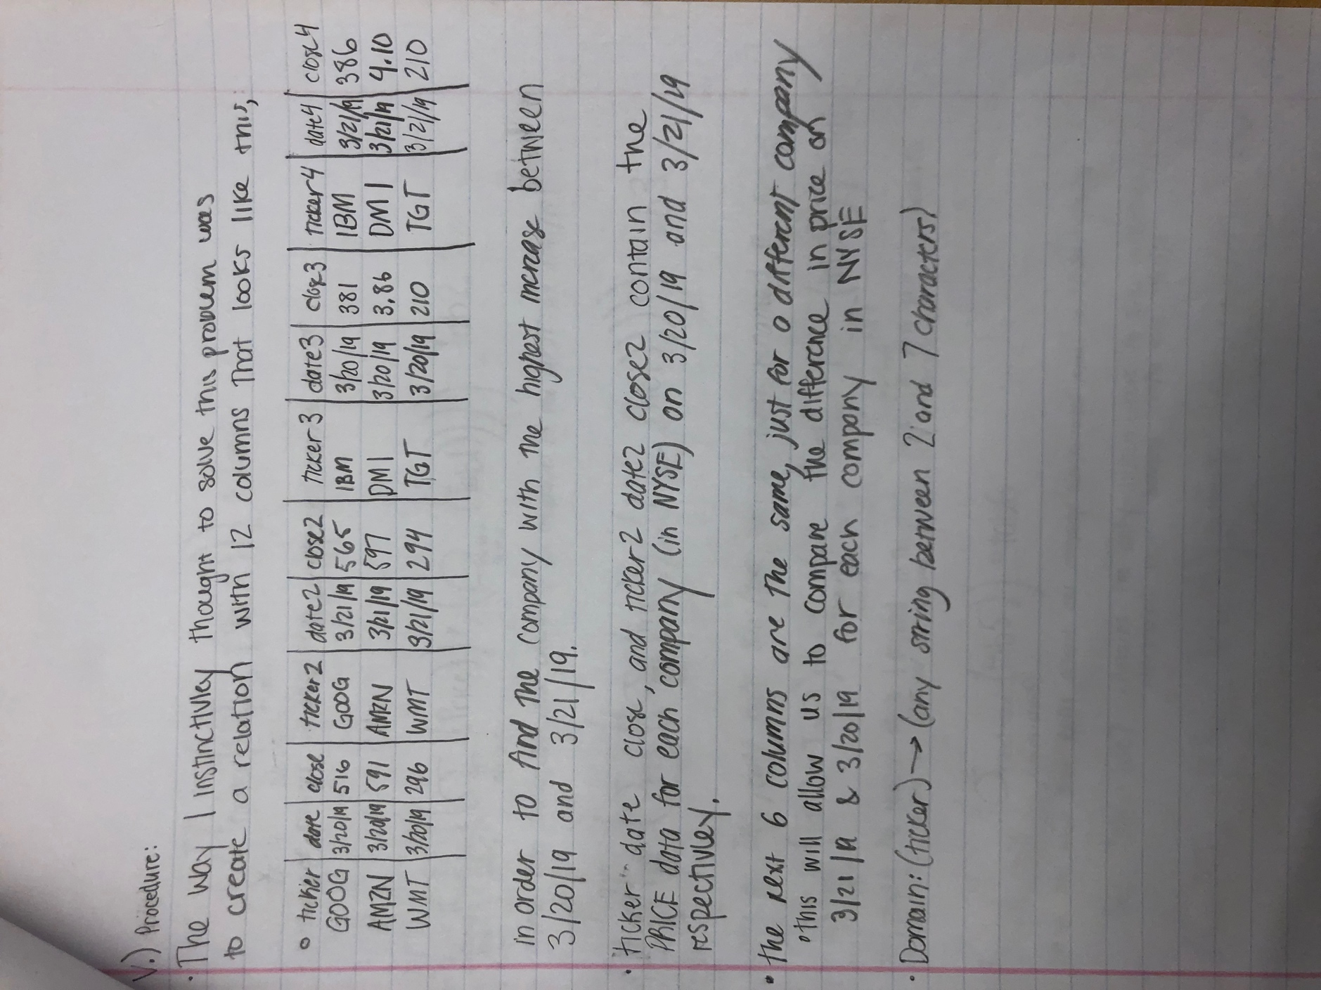

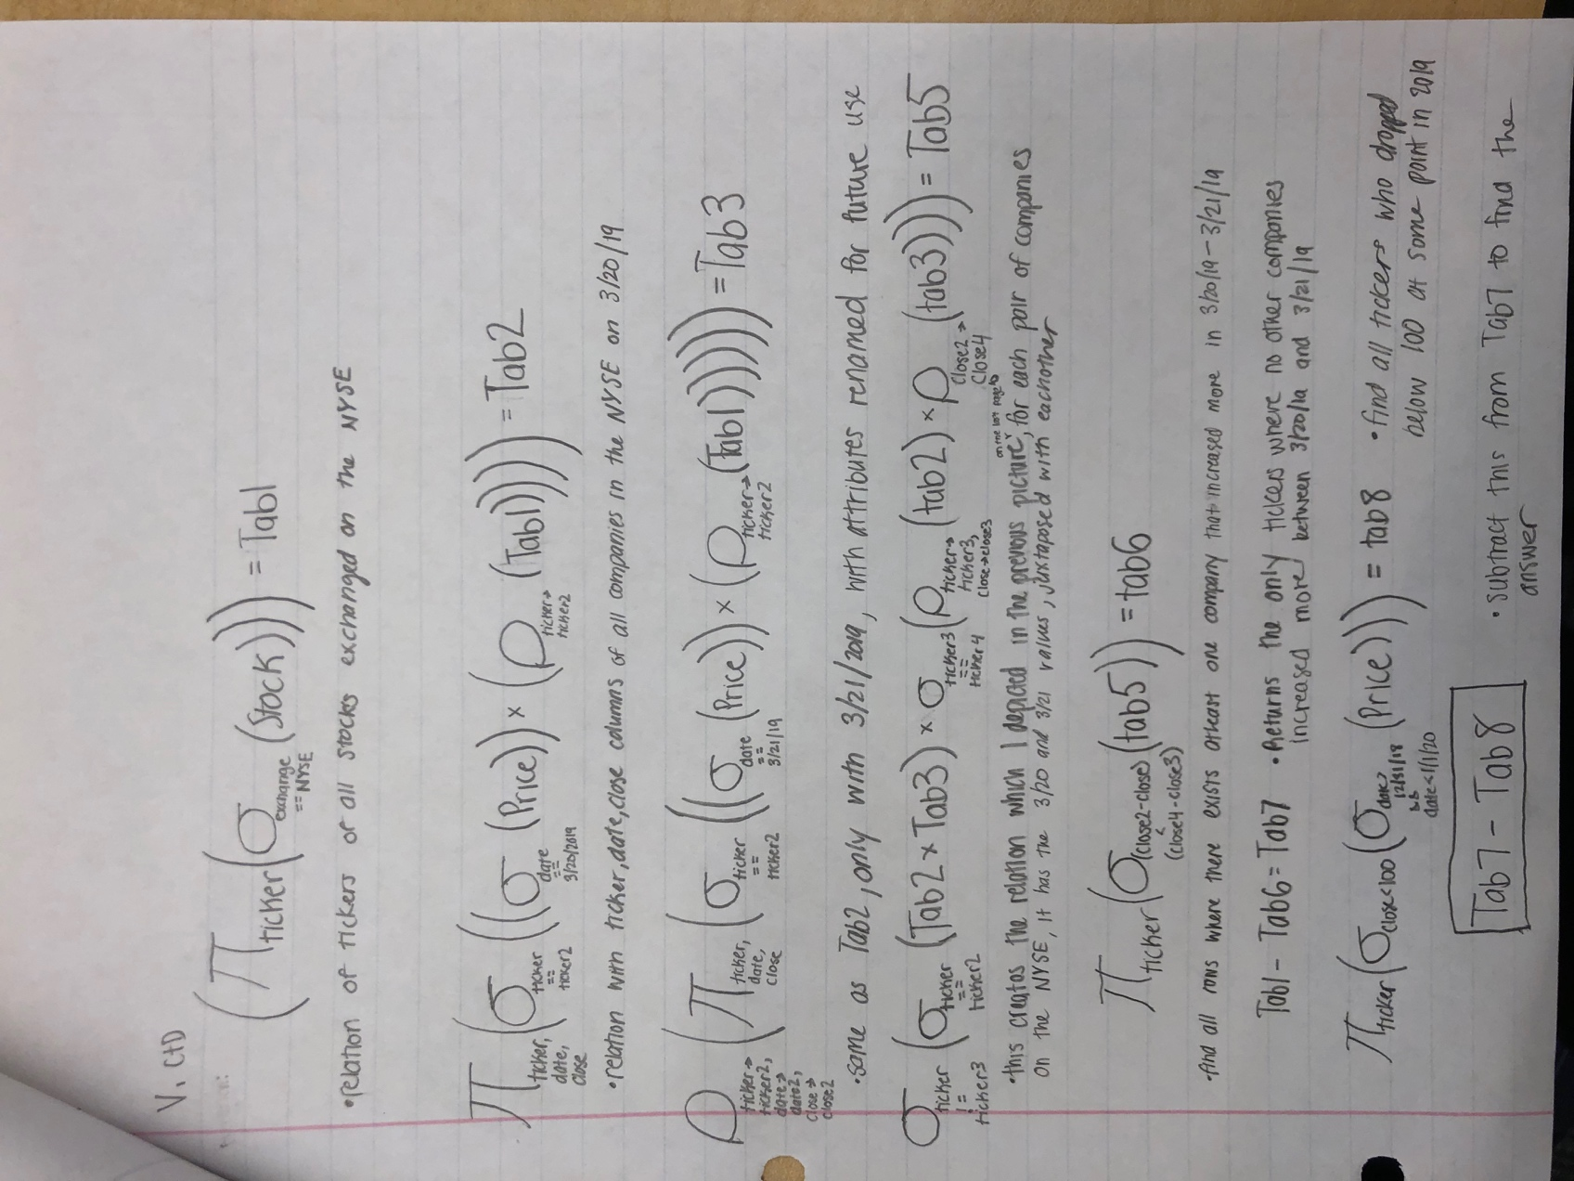

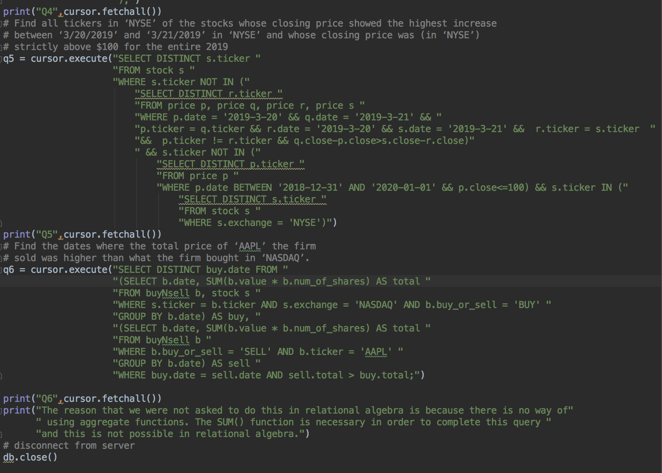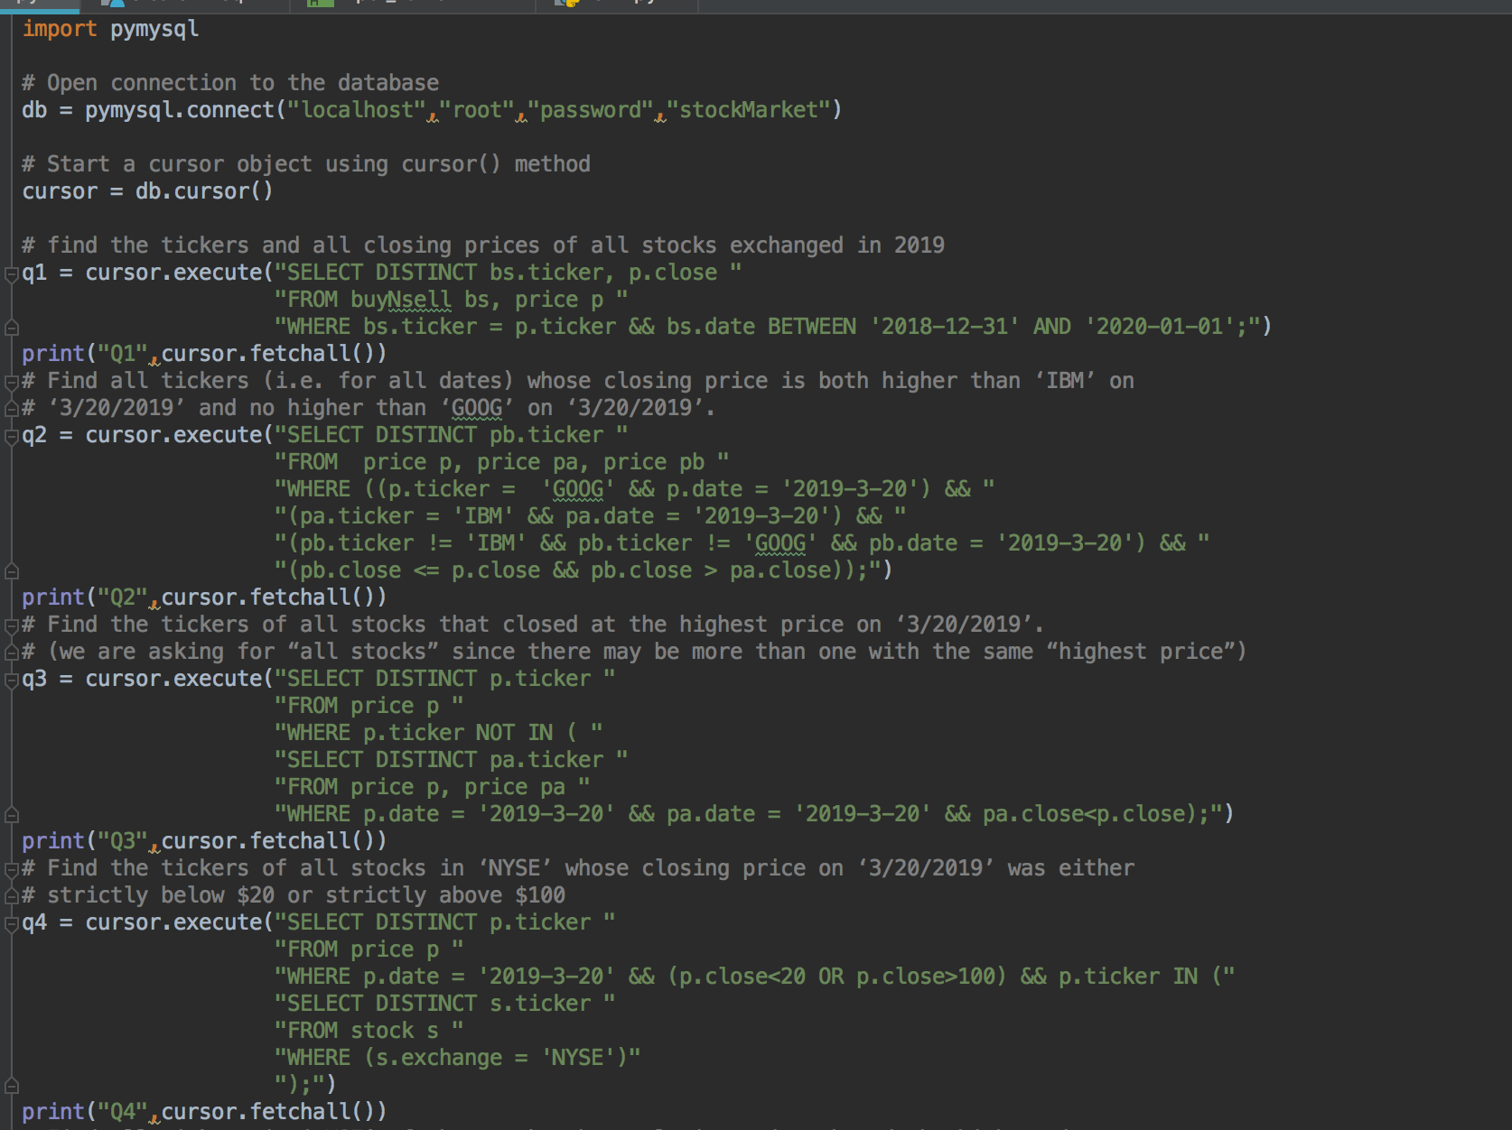2. The same report should contain all SQL queries. Again you can add a brief explanation if you want.

3. In the same report, you should list all the NEW entries you made to the database provided in the end of the Lab Exercise.

New Entries to the database:

INSERT INTO stock (ticker, exchange) VALUES

(‘JNJ’, ‘NYSE’),

(‘TLRY’, ‘NYSE’);

INSERT INTO price (ticker, date, close) VALUES

(‘TLRY’, ‘2019-3-20’, 101),

(‘TLRY’, ‘2019-3-21’, 198),

(‘TLRY’, ‘2019-3-22’, 200),

(‘JNJ, ‘2019-3-20’, 137.5),

(‘JNJ, ‘2019-3-21’, 138),

(‘JNJ, ‘2019-3-22’, 137);

INSERT INTO buyNsell (buy_or_sell, ticker, date, timestamp, value, num_of_shares) VALUES

(‘SELL’, ‘AAPL’, ‘2019-3-22’, 100, 2000);

4. In the same report, you should show the result of each of your queries on the Database instance you used (i.e. the given one + the entries you added).

Q1:

(('AAPL', 100.0), ('AAPL', 101.5), ('AAPL', 106.5), ('GOOG', 100.0), ('GOOG', 130.0), ('GOOG', 110.0), ('IBM', 72.0), ('IBM', 70.0), ('IBM', 10.0), ('MSFT', 184.5), ('MSFT', 188.5), ('MSFT', 210.0))

Q2:

(('AAPL',),)

Q3:

(('MSFT',),)

Q4:

(('JNJ',), ('TLRY',))

Q5:

(('TLRY',),)

Q6:

((datetime.date(2019, 3, 22),),)

5. In the same report, you should provide screenshots for your web application and the tests you performed.

